April 9, 2018
Press Release
CAC Holdings Corporation
CAC Holdings Partners with Chinese Venture Capital
to Expand Its Inbound Business

CAC Holdings Corporation (head office: Chuo-ku, Tokyo; President and CEO: Akihiko Sako; hereinafter “CAC Holdings”) is pleased to announce that it has concluded a basic agreement on an inbound business partnership with Suzhou Tongcheng Zhongchuang Incubator Service Co., Ltd. (head office: Suzhou City, China; General manager: Jacky Lou; hereinafter “Tongcheng Zhongchuang”), a Chinese venture capital firm. Based on this partnership, CAC Holdings will promote and expand the CAC Group’s inbound businesses by finding promising inbound-related start-ups from Tongcheng Zhongchuang’s networks, providing funds to those start-ups and partnering with them.

Tongcheng Zhongchuang is a venture capital firm whose parent company is Tongcheng Holdings Co. Ltd. (head office: Suzhou City, China; CEO: Wu Zhi Xiang; hereinafter “Tongcheng Holdings”), which manages the third largest Chinese online travel agency (TONGCHENG LVYOU (http://www.ly.com/)). Tongcheng Zhongchuang utilizes the management know-how and human networks of Tongcheng Holdings and focuses on corporate development as well as the provision of funds.

CAC Holdings will develop services for Chinese visitors in Japan with inbound-related start-ups that the company funds and partners with through the partnership agreement as part of the CAC Group’s inbound businesses. In addition, CAC Holdings will also provide IT support, utilizing the CAC Group’s technological capability, and support the growth of start-ups together with Tongcheng Zhongchuang.

In its mid-term management strategy that started this year, the Group regards capturing the rapidly expanding inbound business as one of its key initiatives, and is taking steps to pursue this. This latest partnership followed the Group’s funding of a company that provides services for reservations and billing to restaurants for foreign visitors in Japan, which was announced in March. The Group will also engage in medical tourism and regional revitalization while expanding its new inbound business.

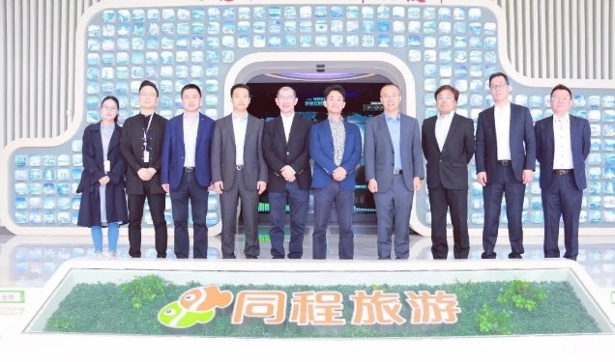
Members of the Tongcheng Group and CAC Group employees

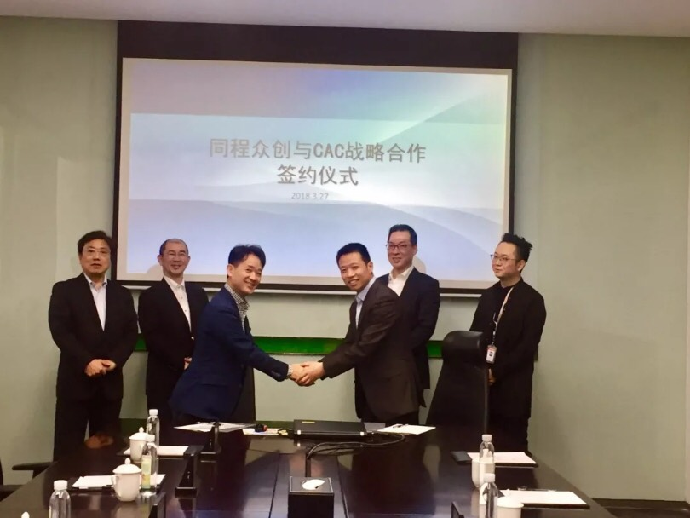
The signing ceremony
About CAC Holdings
CAC Holdings Corporation is a holding company of the CAC Group, which provides IT and healthcare services in Japan and overseas. The CAC Group offers a wide range of services, including IT services and HR BPO services providing management solutions for businesses, pension management systems and pension system research in social security fields, and services supporting pharmaceutical development. Through these services and activities, we contribute to building a better society.
URL: https://www.cac-holdings.com/eng/

Contacts
CAC Holdings Corporation, Corporate Planning Dept., Enterprise Value Up Group
E-mail: prir@cac.co.jp

* The names of companies, products and other matters presented in this document may
include the trademarks or registered trademarks of the companies.

End

